Paper Title of Translational Bioinformatics Conference 2011
First A. Author¹, Second B. Author¹, Third C. Author^{1,2}
¹Seoul National University Biomedical Informatics (SNUBI), ² Human Genome Research Institute, Seoul National University College of Medicine, Seoul 110799, Korea
Abstract
Abstracts are written in 10 pt Times Italic.

Introduction
This template should be used as a starting point for TBC 2011 submissions. A template in Microsoft Word is available on the TBC 2011 webpage at http://www.snubi.org/TBC2011/.

Methods
The body of the text is a set of body text paragraphs defined as follows:
- 10pt Times font
- Single space, defined as 12pt
- There is no indentation for the first line of a paragraph
Equations should be numbered serially on the right-hand side by Arabic numerals in parentheses.
$\sum{\text{Equation}}=\text{Equations}$

Results

Figures are sequentially numbered in numeric fashion with the figure title and number below the figure as shown in Figure 1. Figures are referred to in the text by the figure number.

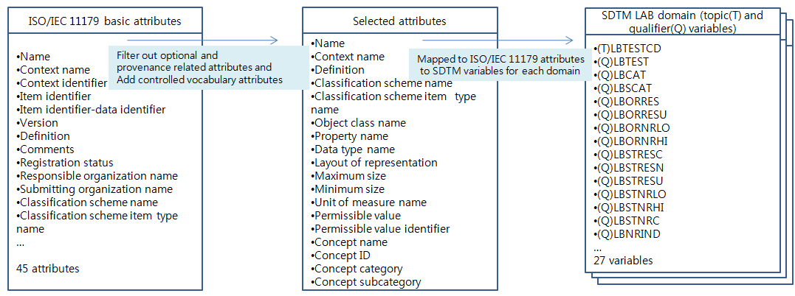
Figure 1. Mapping rule generation process.

Tables are sequentially numbered in numeric fashion with the table title and number above the table. Table column headings should be in 10pt bold. Tables are referred to in the text by the table number.

Table 1. Fragment of SDTM mapping rules in MH and LB
SDTM domain | Topic and qualifier variable | Source attributes (ª: ISO/IEC 11179, ^{b}: clinical trial result file)
MH | MHTEMR | Name ª
MH | MHMODIFY
MH | MHDECOD | Concept name ª
MH | MHCAT | Concept category ª
MH | MHSCAT | Concept sub category ª
MH | MHPRESP | If MHTERM is in CRF, ‘Y’ otherwise null ^{b}
MH | MHOCCUR | Result value ^{b}
MH | MHBODSYS | Concept category ª
LB | LBTESTCD | Name ª
LB | LBTEST | Concept name ª
LB | LBCAT | Concept category ª
LB | LBSCAT | Concept sub category ª
LB | LBORRES | Result value ^{b}
LB | LBORRESU | Unit of measure ª
LB | LBORNROLO | Minimum size ª
LB | LBORNROHI | Maximum size ª
LB | LBLOINC | Concept ID ª

Conclusion
Although a conclusion may review the main points of the paper, it must not replicate the abstract.

Acknowledgments
The authors would like to thank those that have supported you and your work.

References
- Kuchinke W, Aerts J, Semler SC, Ohmann C. CDISC standard-based electronic archiving of clinical trials. Methods Inf Med 2009; 48 (5):408-413.
- Clinical Data Interchange Standards Consortium (CDISC) registered solutions providers chart. Available at http://www.cdisc.org/rsp-chart Accessed July 28, 2010.

